**ERASMUS+ PROGRAMME**

**Project Number: 585980-EPP-1-2017-1-DE-CBHE-JP**

**MediTec:**

**Training for Medical Education via Innovative e-Technology**

**Title: Dissemination of MediTec**

**Jordan University of Science and Technology**

**Date: Feb, 2018– May, 2019**

**ERASMUS+ PROGRAMME**

**Project Number: 585980-EPP-1-2017-1-DE-CBHE-JP**

**MediTec:**

**Training for Medical Education via Innovative e-Technology**

**Title: \*\*\*\*\*\*\***

**Venue: \*\*\*\*\*\*\***

**Date: \*\*\*\*\*\*\***

# Table of Contents:

1. Erasmus+ Workshop ………………………………………………………..………………………..……...4
2. GCREEDER 2018…………………………………………………………………………………………….......5
3. INVENT Final Conference………………………………………………………………...……………….…6
4. The XXX Congress of the INTERNATIONAL Academy of Pathology.………………………7
5. Scientific Day of the Faculty of Medicine-UJ ……………………………………………...8
6. Window of Collaboration……………………………………………………………………………………..9
7. AIChE conference and Info day…………………………………………………………………………...10
8. Job Fair and Info day………………………………………………………………………………………......11
9. Third Agriculture Exhibition and Info day…………………………………………………………….12
10. 1st International Staff Week…………………………..…………………………………………………...13

|  |  |  |  |
| --- | --- | --- | --- |
| **Author(s)** | Prof. Fahmi Abu Al-Rub  Eng. Ruba Hasan | | |
| **Organization Name(s)** | Jordan University of Science and Technology (JUST) | | |
| **WP Number** | 5 | | |
| **WP Leader(s)** | INT@E | | |
| **Due Date of Delivery** | along project period | Project Month (expected to be submitted ) | M19 |
| **Submission Date** | May 22, 2019 | Project Month  (real date of submission) | M19 |
| **Approved Date** |  | | |
| **Total Number of Pages** | 14 Pages | | |

1. Erasmus+ Projects Workshop.

Prof. Fahmi Abu Al-Rub, Coordinator of MediTec at JUST, organized workshops for all Faculty member at JUST on ERASMUS+ projects in February 2018. MediTec project was among the projects that were introduced to the participants.

Avenue: Jordan, Irbid/ALRamtha, JUST

Sector: Academic

Target Groups: National Higher Education Institutions, Students from different JO universities.

Number of Participants: More than 25

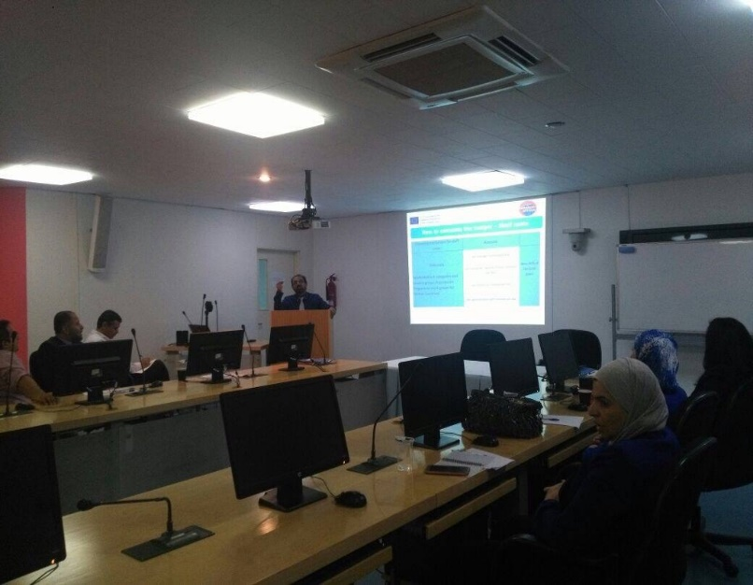

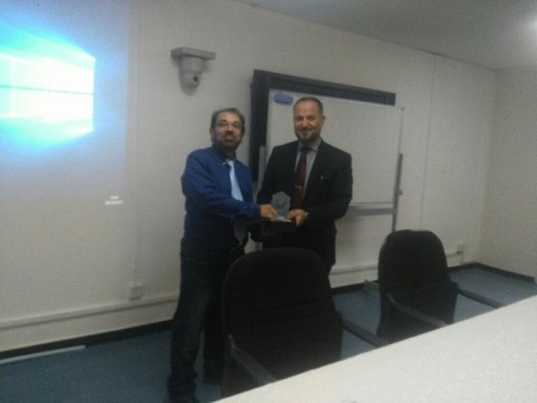

1. GCREEDER 2018

The dissemination event was conducted during the 6th conference of GCREEDER 2018, which was held at the University of Jordan during the period April 3-5, 2018 under the patronage of HRH Prince Hamzeh Ibn ALHussein. The MediTec project with Roll up and brochures was in the exhibition hall of the GCREEDER 2018. The Attendance were from all industrial, academic and research fields, from Jordan and around world.

Avenue: Jordan, Amman, UJ

Sectors: Industrial and Academic

Target Groups: Higher Education Institutions, Students from different JO universities, International and national Companies, industrial decision makers.

Attendance: More than 1000

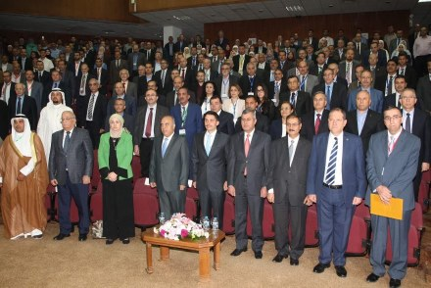

1. INVENT Final Conference

Dissemination activity for the MediTec project at MOVENPIC, Dead Sea was done during the INVENT Final Conference (September, 2018).

Avenue: Jordan, Dead Sea, MOVENPIC

Sectors: Industrial and Academic

Target Groups: Higher Education Institutions, Students from different JO universities, International and national Companies, industrial decision makers.

Attendance: More than 150

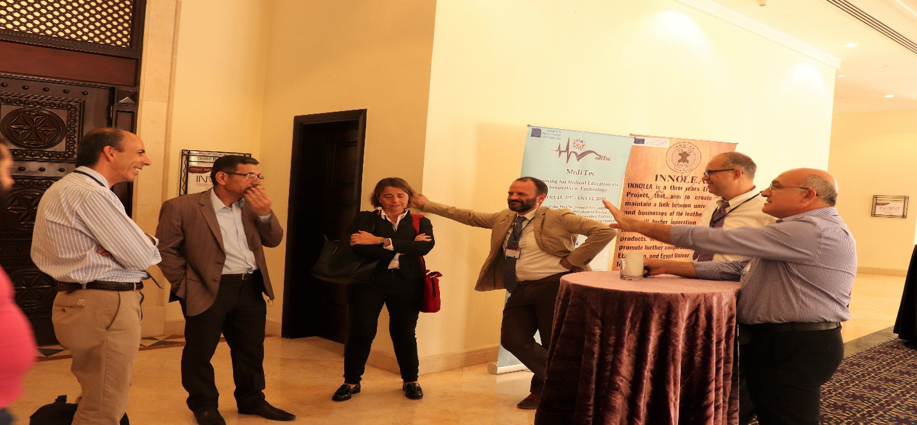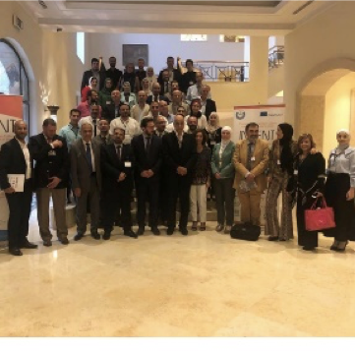

1. The XXX Congress of the INTERNATIONAL Academy of Pathology.

Prof. Ismail Matalkeh, Medicine Faculty member and one of the members of MediTec Project at JUST, mentioned MediTec project in the presentations and projects related to the medical education. The conference took place id the DeadSea, Jordan during the 14-18 October, 2018.

Avenue: King Hussein Bin Talal Conference Center Dead Sea, Jordan

Attendance: More than 1000

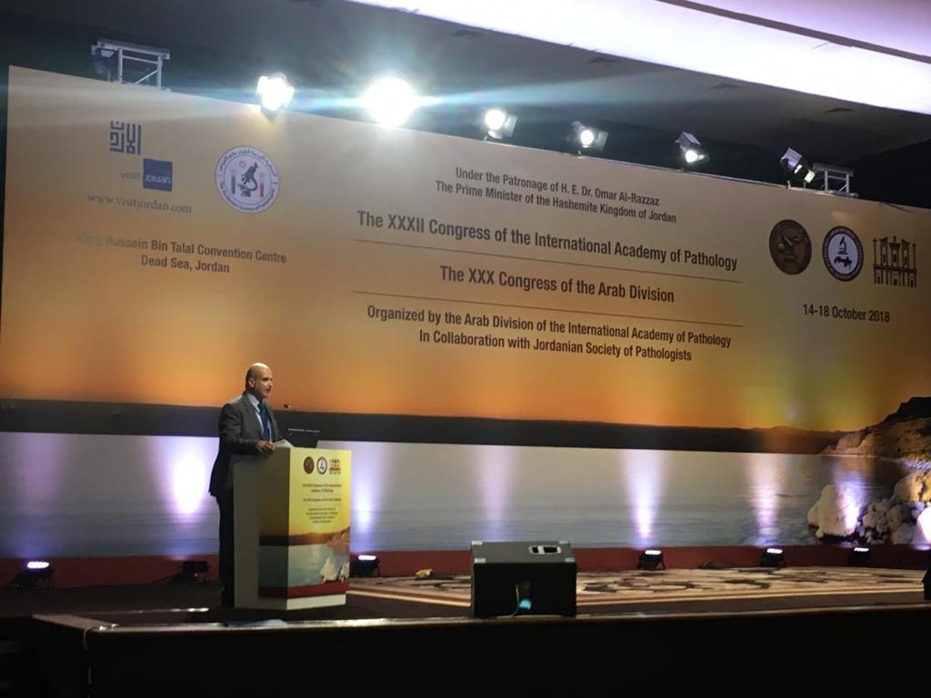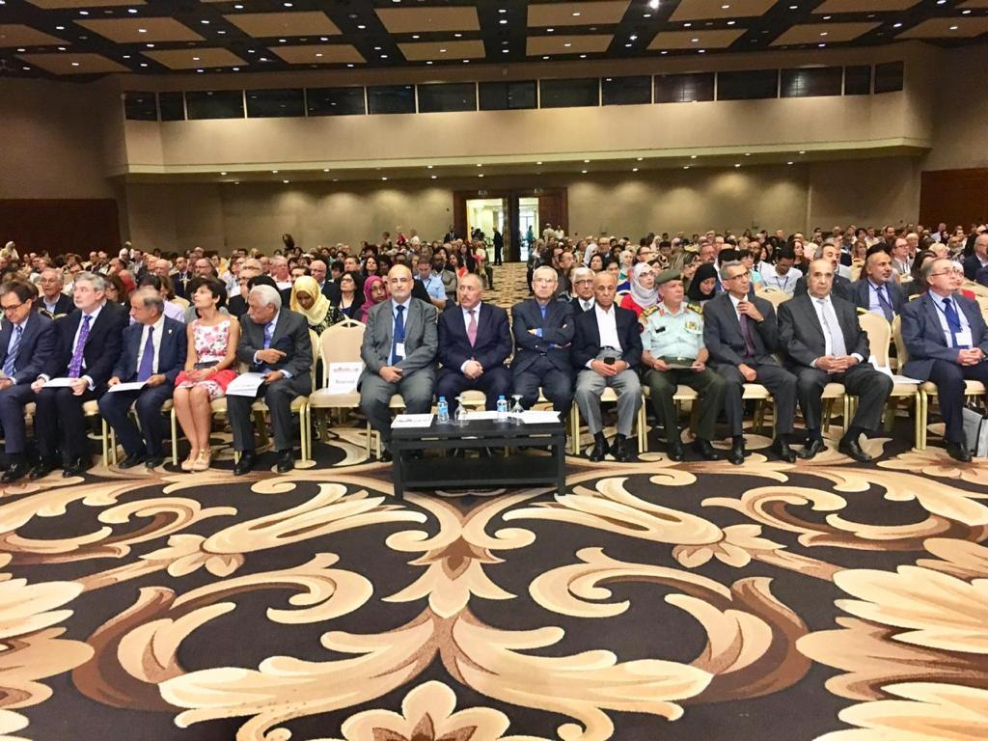

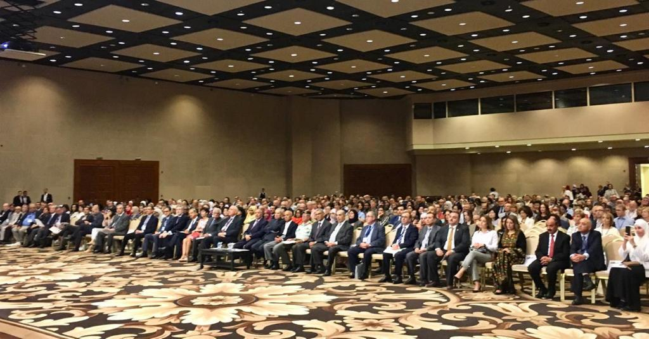

|  |
| --- |
| 1. Scientific Day of the Faculty of Medicine-UJ |
| ​JUST and UJ participated in the dissemination activities of the MediTec at the Scientific Day of the Faculty of Medicine at UJ, which was held on April 11, 2019. A booth for the MediTec was offered by the Faculty of Medicine, where MediTec roll-up, brochures, and other dissemination materials were presented.  Avenue: University of Jordan, Faculty of Medicine.  Attendance: more than 1000.  Sector: Academic  Target Group: Staff members and students.  IMG-20190411-WA0020.jpgIMG-20190411-WA0012.jpg |
|  |

1. The Window of Collaboration

Dissemination activity for the MediTec project at the Info day “ Window of Collaboration” which was organized at UJ on April 17, 2019

Avenue: Jordan, Amman, UJ

Sector: Industrial and Academic

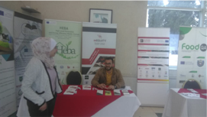Target Groups: International and national Higher Education Institutions, Students from different JO universities.

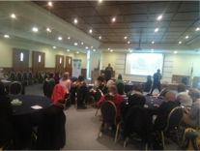

1. AlChE Conference

Dissemination activity for the INNOLEA project at AIChE conference and Info day which was organized at JUST on April 22, 2019.

Avenue: Jordan, Irbid/AlRamtha, JUST

Sector: Academic

Target Groups: International and national Higher Education Institutions, Students from different JO universities (Engineering Faculties)

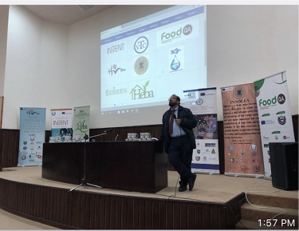Attendance: more than 300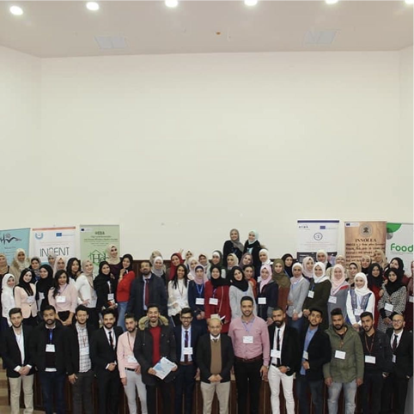

1. Job Fair and Info day

Dissemination activity for the MediTec project at the Job Fair and Info day which was organized at JUST on April 23, 2019.

Avenue: Jordan, Irbid/AlRamtha, JUST

Sectors: Academic and Industrial

Target Groups: International and national Higher Education Institutions, Students from different JO universities (different Engineering and Science Faculties), Industrial Sector.

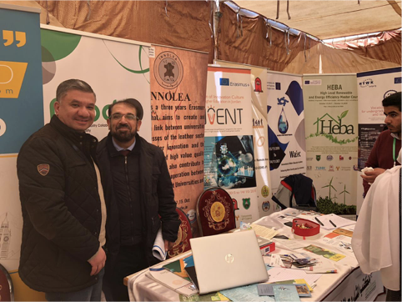

1. Third Agriculture Exhibition and Info day

Dissemination activity for the MediTec project at the Third Agriculture Exhibition and Info day which was organized at JUST on April 24, 2019.

Avenue: Jordan, Irbid/AlRamtha, JUST

Sector: Academic and Industrial

Target Groups: International and national Higher Education Institutions, Students from different JO universities (different Engineering and Science Faculties), Industrial Sector

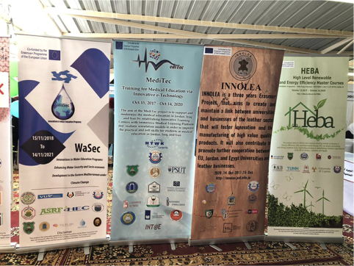

1. 1st international staff week.

Dissemination activity for the MediTec project at 1st International Staff Week which was organized at JUST on April 30, 2019.

Avenue: Jordan, Irbid/AlRamtha, JUST

Sector: Academic and Industrial

Target Groups: International and national Higher Education Institutions.

